**YOU REMEMBER WHEN...?   All the girls had ugly gym uniforms?   
  
  
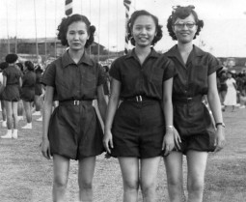  
  
  
  
It took five minutes for the TV warm up?   
  
  
  
  
Nearly everyone's Mom was at home when the kids got home from school?   
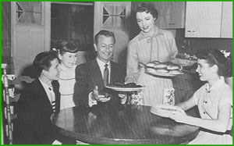  
  
  
  
  
  
   
  
  
When a quarter was a decent allowance?  
  
  
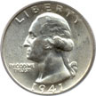**

**You'd reach into a muddy gutter for a penny?   
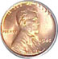  
  
Your Mom wore nylons that came in two pieces?   
**

**All your male teachers wore neckties and female teachers had their hair done every day and wore high heels?   
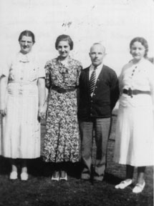**

**You got your windshield cleaned, oil checked, and gas pumped, without asking, all for free, every time?   
And you didn't pay for air? And, you got trading stamps to boot?  
 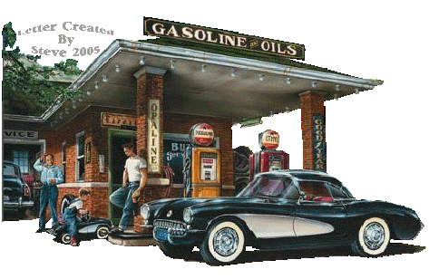**

**Laundry detergent had free glasses, dishes or towels hidden inside the box?  
 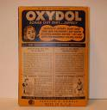  
  
  
It was considered a great privilege to be taken out to dinner at a real restaurant with your parents?   
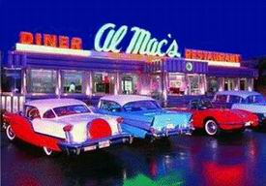**

**They threatened to keep kids back a grade if they failed.  . and they did?  
 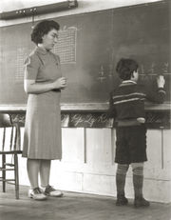**

**When a 57 Chevy was everyone's dream car.to cruise, peel out, lay rubber or watch submarine races, and people went steady?  
  
  
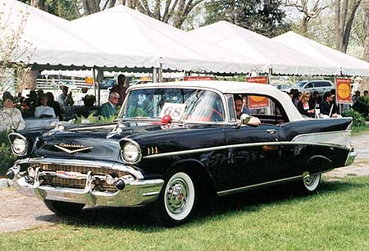**

**No one ever asked where the car keys were   
because they were always in the car,   
in the ignition, and the doors were never locked?  
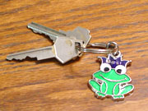  
  
  
  
  
  
  
  
  
  
  
Stuff from the store came without safety caps and hermetic seals because no one had yet tried to poison a perfect stranger?   
cid:14.503314385@web46015.mail.sp1.yahoo.com  
  
  
And with all our progress, don't you just wish, just once, you could slip back in time and savor the slower pace,and share it with the children of today?   
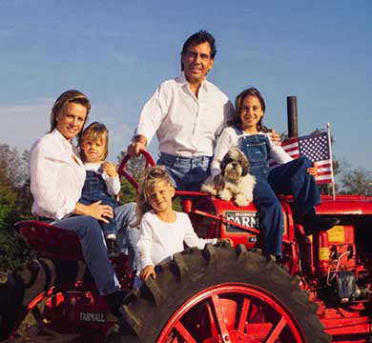**

**When being sent to the principal's office was nothing   
compared to the fate that awaited the student at home?  
**

**Basically we were in fear for our lives, but it wasn't because of drive-by shootings, drugs, gangs, etc. Our parents and grandparents were a much bigger threat!  But we survived because their love was greater than the threat.   
**

**Laurel and Hardy,Howdy Dowdy and the Peanut Gallery,the Lone Ranger, The Shadow Knows,  
Nellie Bell, Roy and Dale, Trigger and Buttermilk.   
  
  
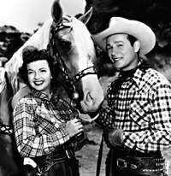**

**I am sharing this with you today because it ended with a double dog dare to pass it on. To remember what a double dog dare is, read on.  And remember that the perfect age is somewhere between old enough to know better and too young to care.**

**How many of these do you remember?  
  
  
Candy cigarettes  
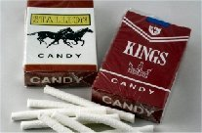  
  
Wax Coke-shaped bottles with colored sugar water inside   
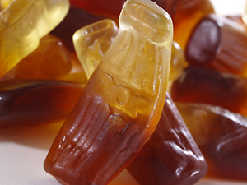  
  
  
Soda pop machines that dispensed glass bottles  
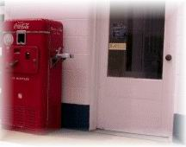**

**Coffee shops with tableside jukeboxes  
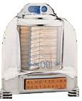  
  
Blackjack, Clove and Teaberry chewing gum  
 cid:23.503314385@web46015.mail.sp1.yahoo.com  
Home milk delivery in glass bottles with cardboard stoppers  
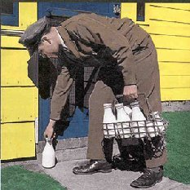  
  
Newsreels before the movie   
P.F Fliers   
  
  
  
  
Telephone numbers with a word prefix...(Raymond 4-601). Party lines   
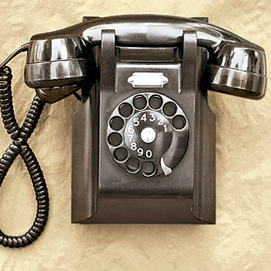**

**Howdy Dowdy  
  
  
  
  
Hi-Fi's   
45 RPM records  
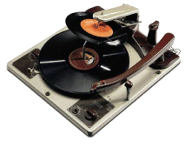**

**78 RPM records!  
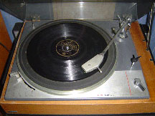**

**Green Stamps   
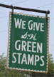  
  
  
Metal ice cubes trays with levers   
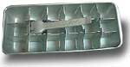**

**Roller-skate keys   
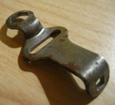**

**Cork pop guns   
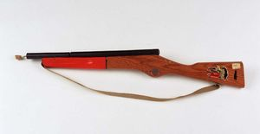**

**Studebakers  
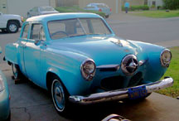  
  
  
Washtub wringers   
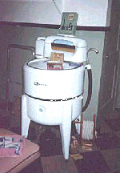**

**Erector Sets   
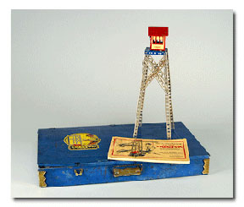  
  
  
  
15 cent McDonald hamburgers  
  
  
cid:37.503314385@web46015.mail.sp1.yahoo.com**

**5 cent packs of baseball cards - with that awful pink slab of bubble gum**

**Penny candy**

**25 cent a gallon gasoline  
  
  
   
  
  
Do you remember a time when...**

**'Race issue' meant arguing about who ran the fastest?   
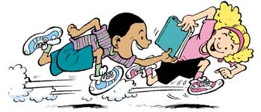**

**Catching the fireflies could happily occupy an entire evening?  
  
  
  
  
  
  
   
   
  
  
The worst thing you could catch from the opposite sex was 'cooties'?  
   
   
Having a weapon in school meant being caught with a slingshot?  
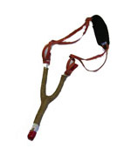  
  
  
   
  
  
'Oly-oly-oxen-free' made perfect sense?   
  
  
Spinning around, getting dizzy, and falling down was cause for giggles?   
  
  
The worst embarrassment was being picked last for a team?   
  
   
  
  
Baseball cards in the spokes transformed any bike into a motorcycle?   
  
  
Taking drugs meant orange-flavored chewable aspirin?  
 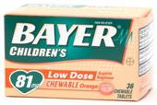**

**Water balloons were the ultimate weapon?  
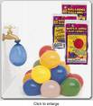**

**If you can remember most or all of these, then you have lived!!!!!!!   
  
  
Pass this on to anyone who may need a break from   
their 'grown-up' life . . .I double-dog-dare-ya!**