Amazing Lake Superior Facts  
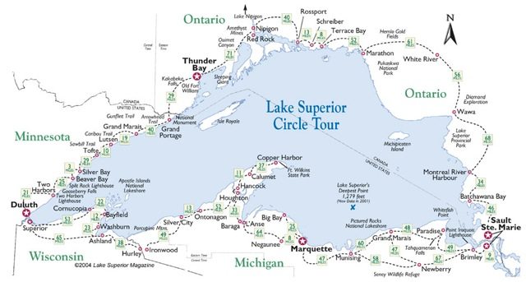

**· Lake Superior contains ten percent of all the fresh water on the planet Earth.  
· It covers 82,000 square kilometers or 31,700 square miles.  
· The average depth is 147 meters or 483 feet.    
· There have been about 350 shipwrecks recorded in Lake Superior .  
· Lake Superior is, by surface area, the largest lake in the world.  
· A Jesuit priest in 1668 named it Lac Tracy, but that name was never officially adopted.  
· It contains as much water as all the other Great Lakes combined, plus three extra Lake Eries .  
· There is a small outflow from the lake at St.  Marys River (Sault Ste Marie) into Lake Huron. but it takes almost two centuries for the water to be completely replaced.  
· There is enough water in Lake Superior to cover all of North and South America with water a foot deep.  
· Lake Superior was formed during the last glacial retreat, making it one of the earth's youngest major features at only about 10,000 years old.  
· The deepest point in the lake is 405 meters or 1,333 feet.  
· There are 78 different species of fish that call the big lake home.  
· The maximum wave ever recorded on Lake Superior was 9.45 meters or 31 feet high.  
· If you stretched the shoreline of Lake Superior out to a straight line, it would be long enough to reach from Duluth to the Bahamas .  
· Over 300 streams and rivers empty into Lake Superior with the largest source being the Nipigon River .  
· The average underwater visibility of Lake Superior is about 8 meters or 27 feet, making it the cleanest and clearest of the Great Lakes.  Underwater visibility in some spots reaches 30 meters.  
· In the summer, the sun sets more than 35 minutes later on the western shore of Lake Superior than at its southeastern edge.  
· Some of the world's oldest rocks, formed about 2.7 billion years ago, can be found on the Ontario shore of Lake Superior .  
· It very rarely freezes over completely, and then usually just for a few hours.  Complete freezing occurred in 1962, 1979, 2003 and 2009.**

**NOW YOU KNOW**